

Moviemark Tutorial Manual

Camila Gallardo and Mimi Ogunyemi

**Table of Contents**

1. Introduction of Database…………………………………………………….2
2. Features……………………………………………………………………...2

2.1 Registration………………………………………………………….. 2

2.2 Logging into an account………………………………………………3

2.2 Accessing movies……………………………………………………..4

1. Introduction of database

This database allows the user to create an account, log in, and to view the current movies showing in the theater.

1. Features

2.1 Registration

When executed, the file will pop up to show what is displayed below. If you do not have an account, fill in your First and last name, your email, the username you wish to use, and a password.

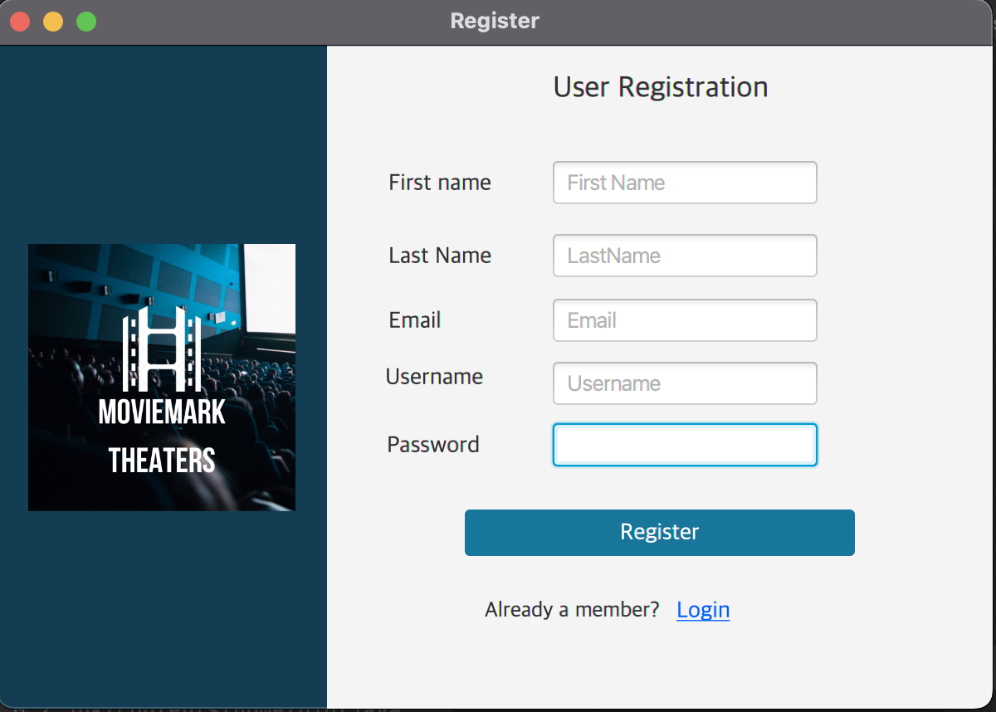

2.2 Logging onto an account

If you already have an account, the login button under the registration button.

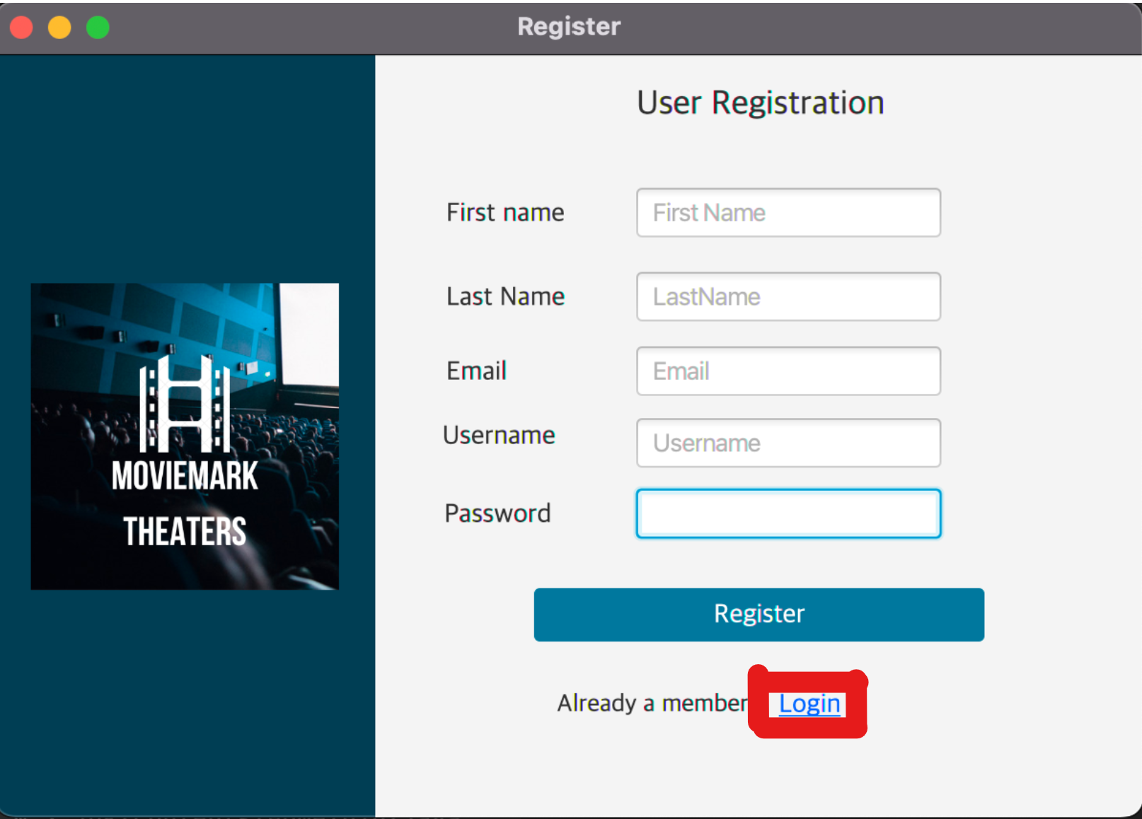

When you click the button, you are brought to the page below. Type in your Username and Password to login.

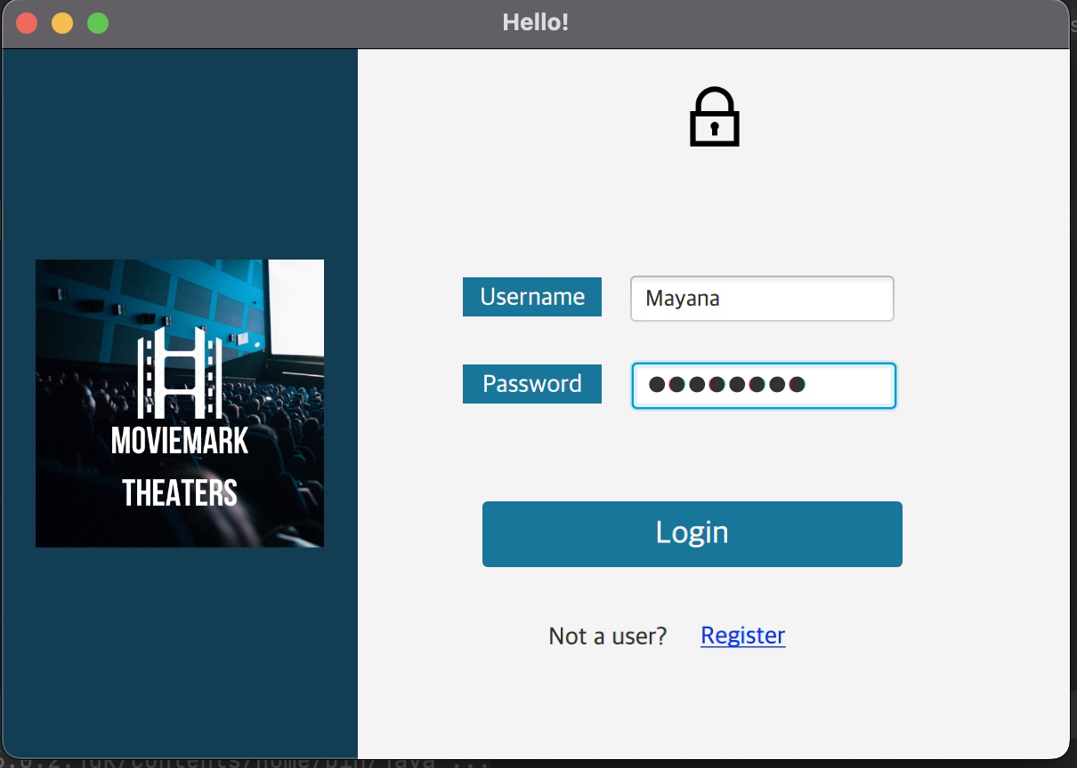

When you have Logged in, you are brought to the page below:

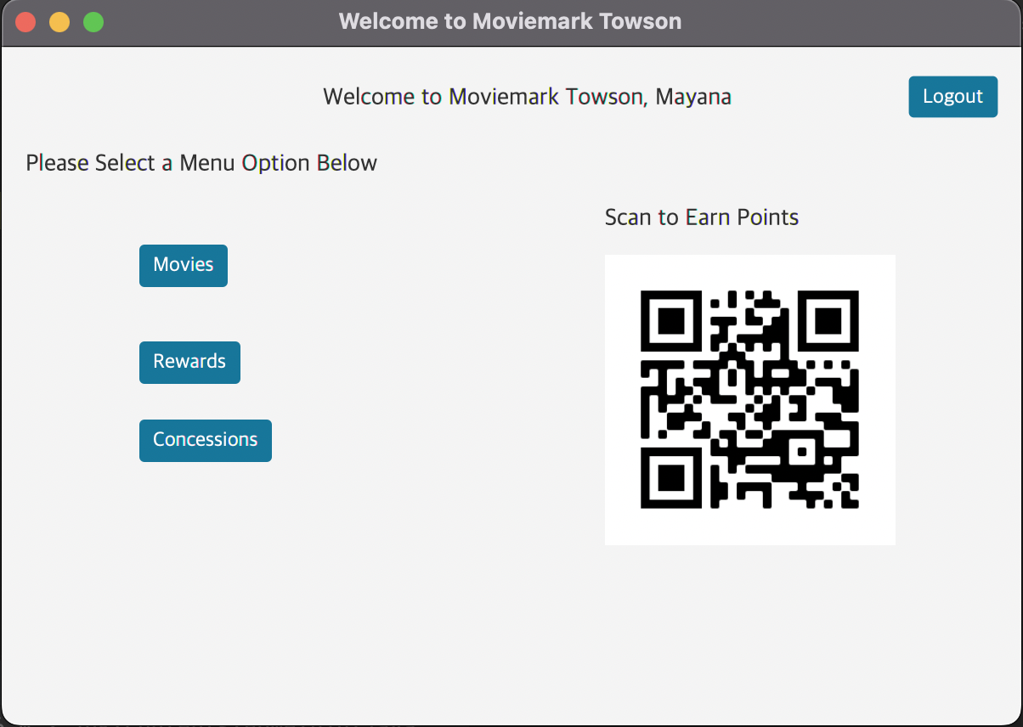

2.3 Accessing Movies that are currently showing:

When logged in, click on the movies button to open up the available movies:

